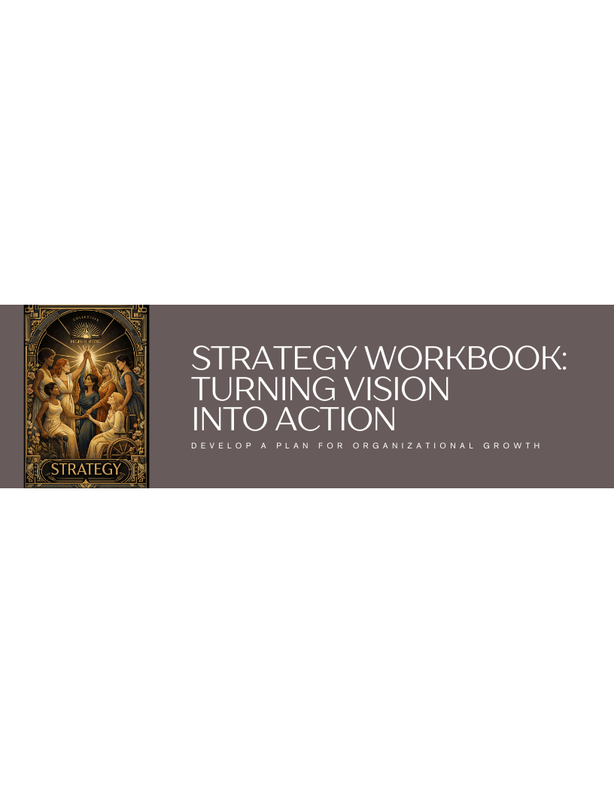
Let’s Begin!
In this activity, you will learn how to make a plan for your work. This plan will help you choose what is important and act on it. You will learn about customers, offers, and marketing.
Here are some key terms:
- Strategy: A plan to reach a goal. In this activity, it means planning your work.
  - For example, the strategy might be to get ten new clients in 90 days.
- Customer: The person who buys your product or service.
  - For example, your customer is someone who needs help with social media.
- Offer: What you sell to your customers.
  - For example, your offer could be a class on how to use social media.
- Marketing: How you tell people about your offer.
  - For example, marketing can be posting on social media.
Tips for Success
Think about what you really want to achieve. Be clear about who your customers are. Make sure your offer is something people want. Choose marketing that works for you. Plan your time carefully.
Read the Following Text
Read the following text carefully. You will use it to complete the tasks that follow.
My Strategy Workbook
This workbook is here to help you plan your work. Take your time to think about each part. There are no wrong answers. You need to find what works for you.
Strategic Focus
What is important right now? You do not have to do everything. Do the right things first.
- What must happen in the next 90 days?
- What seems urgent, but is not?
- What one action would help the most?
Customer Strategy
Who do you help? Know the real person with a real problem.
- Who is your best customer right now?
- What problem are they trying to fix?
- Where do they spend their time?
Offer Strategy
What do you sell? Why does it work?
- What are you offering?
- What does it do for people?
- Why pick this offer?
Positioning and Difference
Why you? Why now?
- What makes you different?
- What do you bring from your life?
- What do you do better?
Revenue Strategy
How does money come in? Money is part of keeping going. Do not make it hard.
- How will you make money in the next 3–6 months?
- What is your main way to make money?
- What other ways could you make money?
Marketing Strategy
How do people find you? Pick what works and what you can keep doing.
- Where are your customers already?
- What way of talking feels right to you?
- What can you do each week?
Operations and Ability
Plan for your real life. If you do not, your plan will not work.
- How many hours a week can you work?
- What jobs make you tired or happy?
- What needs help?
90-Day Action Plan
Turn your plan into action. A plan only works if you act.
- What are the next 3 actions?
- What will success look like in 90 days?
- How will you see if you are doing well?
Making Connections
Key Concept | Your Understanding | Why is this important?
Strategic Focus | It means choosing what is most important right now. | It helps you use your time well.
Customer Strategy | Write your answer here | Write your answer here
Offer Strategy
Positioning and Difference
Revenue Strategy
Marketing Strategy
Operations and Ability
+ Add a row or column as needed
Imagine you have a small business. What is one thing you could do in the next 90 days to help your business grow? | Write your answer here
Who is your ideal customer? What problem do they have that you can solve? | Write your answer here
What is your core offer? What does it deliver to your customers? | Write your answer here
Show What You Learned
Now that you've explored the key concepts, create a project to show your understanding.
Create a short video. In this video, explain your strategy for a new business.
Use Magic Media or Elements to help storyboard or record your idea.
Follow the steps below to complete your creative output:
- Plan your video: Write down what you will say and show.
- Record your video: Make sure you speak clearly.
- Add visuals: Use pictures or text to make your video better. Use Magic Media or Elements to help storyboard or record your idea.
- Share your video: Show it to your class or put it online. Use Magic Media or Elements to help storyboard or record your idea.


Reflect on What You Learned
Now that you’ve explored how ideas can move from understanding to real-world use, take a moment to look back on how you connected concepts, recognized patterns, and applied them to new situations.
What was the most important thing you learned about making a strategy?
Write your answer here.
How will you use what you learned in the future?
What was the hardest part of making a strategy, and how did you fix it?

